Catalog

**Tauren(4 variation)**

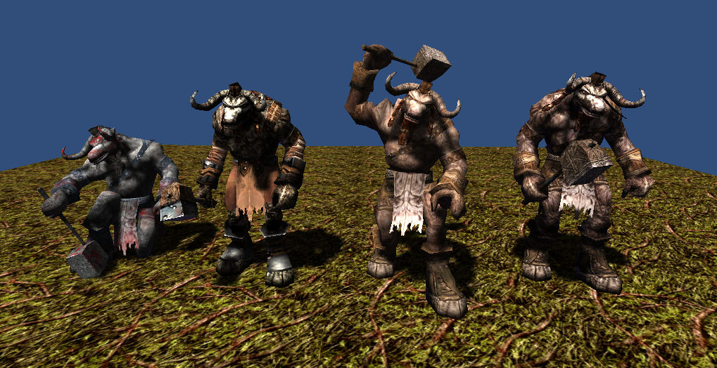

1806 polygons

512x512x32bit 1 texture

5 animations(idle, move, attack, beaten, die)

**MudMan(2 variation)**

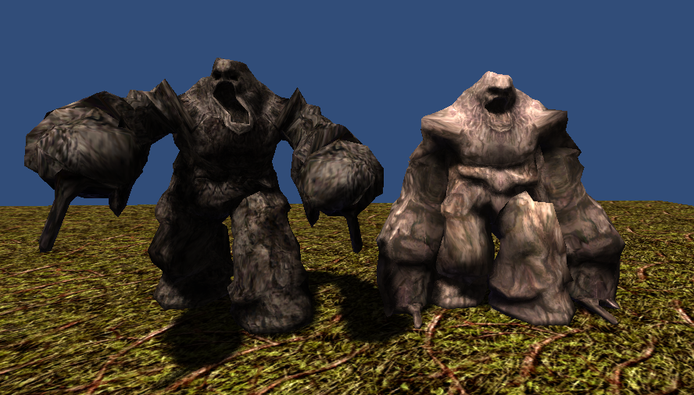

1922 polygons

512x512x24bit 1 texture

5 animations(idle, move, attack, beaten, die)

**Dullahan(4 variation)**

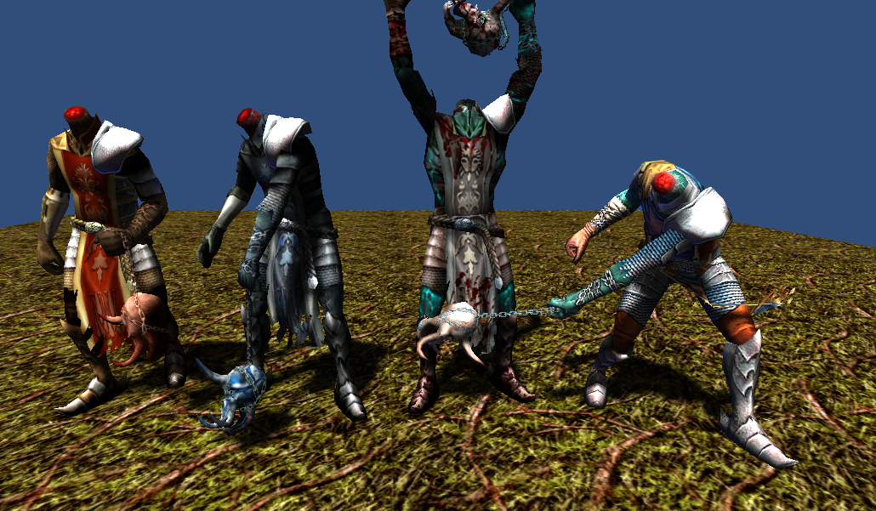

1809 polygons

512x512x32bit 1 texture

5 animations(idle, move, attack, beaten, die)

**Trent(3 variation)**

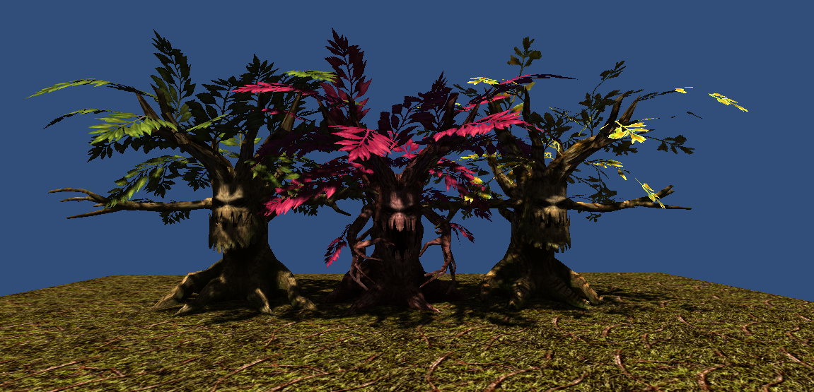

2518 polygons

512x512x32bit 1 texture

5 animations(idle, move, attack, beaten, die)

**Thank you for download.**

**Contact**

Homepage : http://www.studioez.net

E-Mail : admin@studioez.net